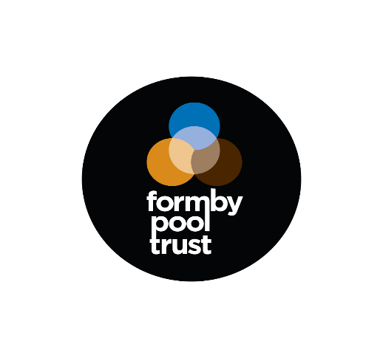

**Post Title:** Cleaning Operative

**Salary:** up to £11.44 per hour

**Hours:** Various shifts available including

Mon - Fri 06.00 – 10.00 & 14.00 – 17.00

Sat - Sun 08.00 – 12.00

**Contract Type:** Permanent (Part-time)

**About this role:**

* Ensure that high standards of hygiene and cleanliness are achieved and maintained throughout the building by completing daily facility cleaning schedules
* Perform a range of cleaning tasks including, but not limited to dusting, hoovering, mopping and deep cleaning washroom facilities and general public areas
* Updating the Duty Manager/Maintenance on any issues or repairs that need to be addressed
* Managing cleaning supplies and informing the Duty Manager when more are required
* Operate equipment as directed, reporting any faults or breakdowns to the Duty Manager
* Follow all Health and Safety regulations, ensuring all cleaning products and equipment are accounted for and stored safely away
* The job will involve interacting with customers on a face to face basis so excellent communication, interpersonal and communication skills are essential.

**Skills and qualities required:**

* Previous experience in a similar role
* Strong interpersonal and problem-solving abilities
* Highly responsible & reliable
* High level of attention-to-detail
* Enthusiasm to develop your skills and knowledge
* Adaptable to change and willingness to embrace new ideas and processes
* Ability to work unsupervised and deliver quality work
* Positive and approachable manner

This post is subject to enhanced DBS disclosure.

**To Apply:**

Applications must be made via the Trust’s application form; CV’s will not be accepted. Please email [vickyk@formbypool.co.uk](mailto:vickyk@formbypool.co.uk) for an application form or please ask the Reception team. If you do not hear from us within three weeks of the closing date, please consider your application unsuccessful.

**Closing Date:** 19th April 2024 **Proposed Interview Date:** TBC